- Exercise 12: Design TM using simulator to accept the input string a^{n}b^{n}
L={ anbn | w∈a+b

Output :

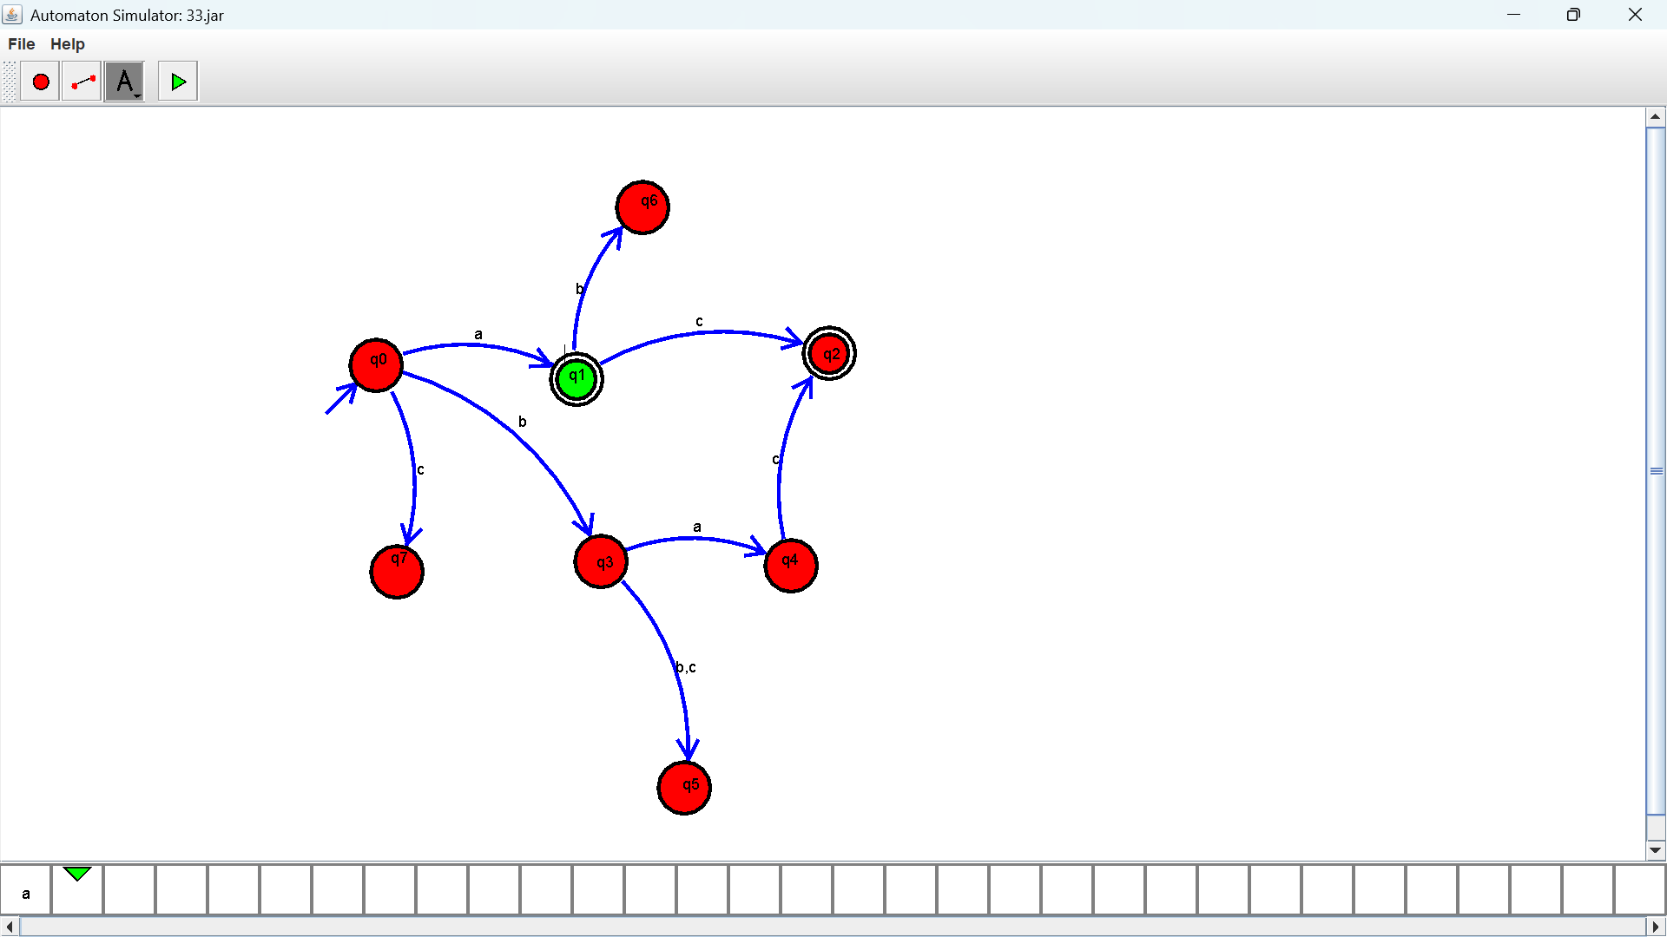

Exercise 13: Design TM using simulator to accept the input string a^{n}b^{2n}
Output :
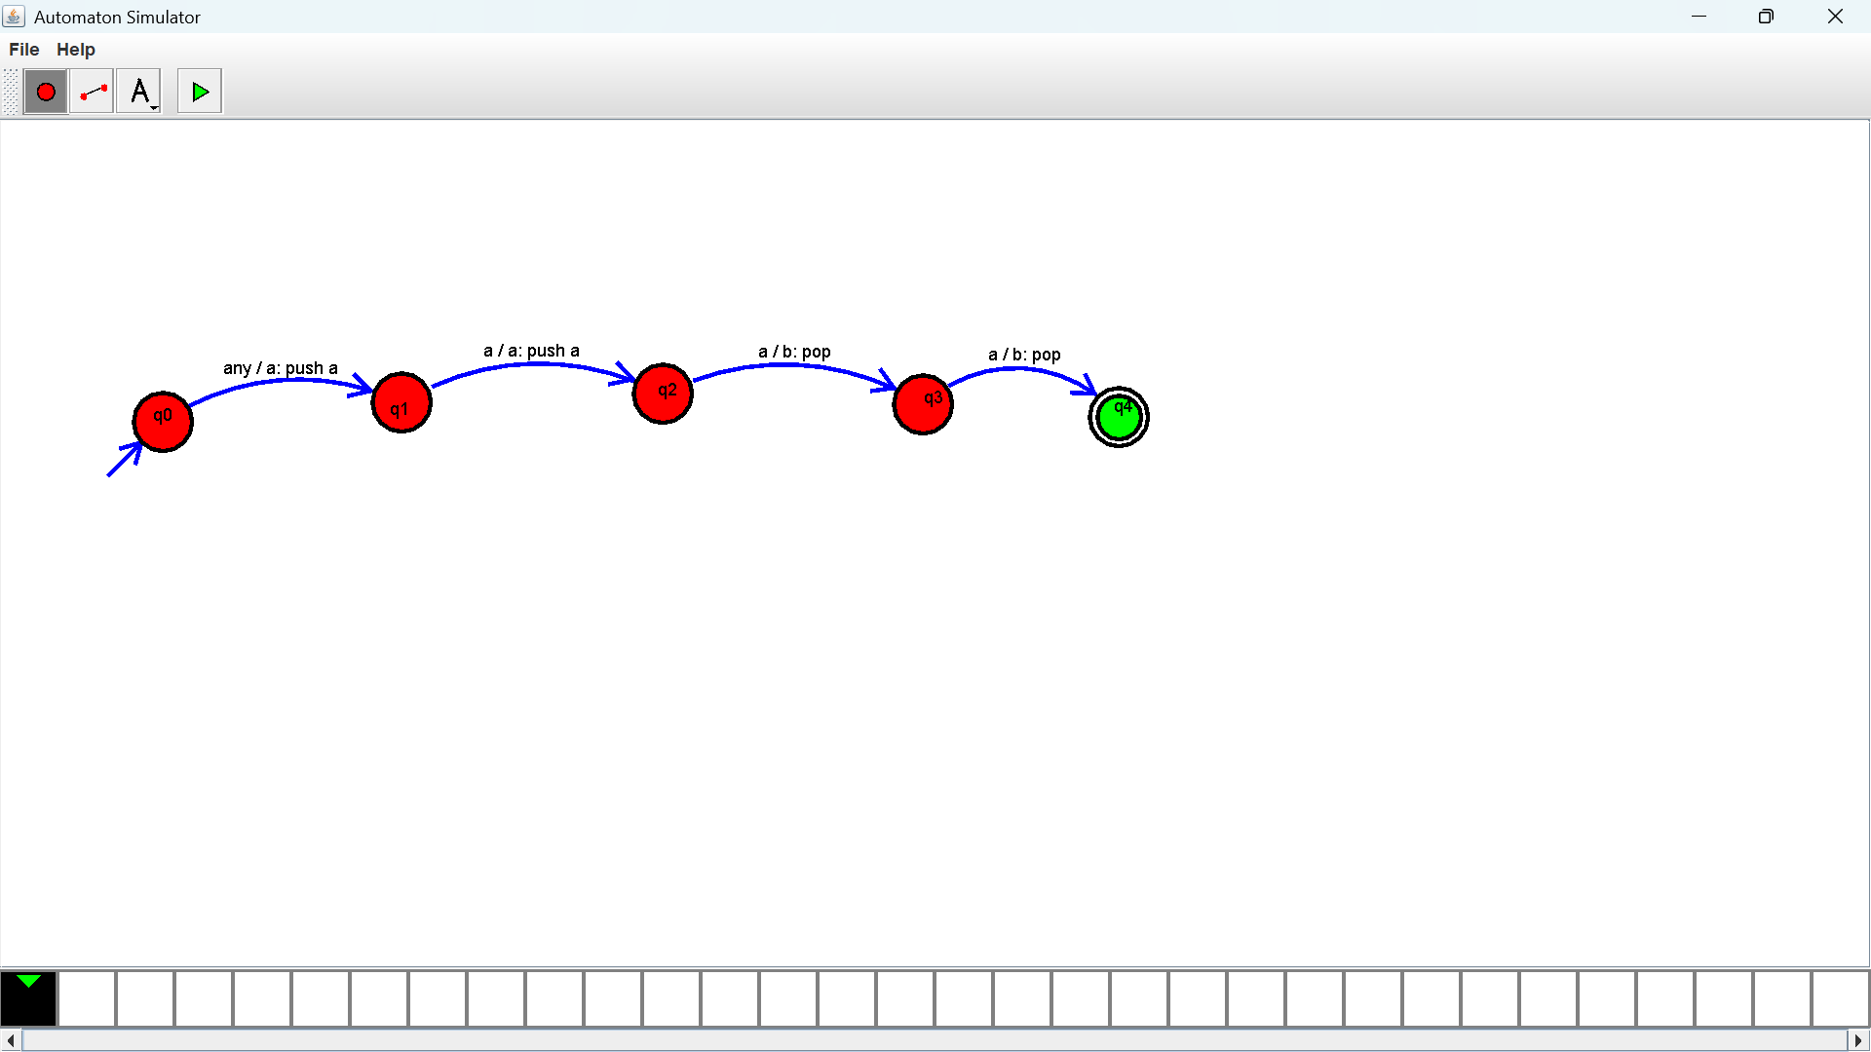

Exercise 14: Design TM using simulator to accept the input string Palindrome ababa
Output :

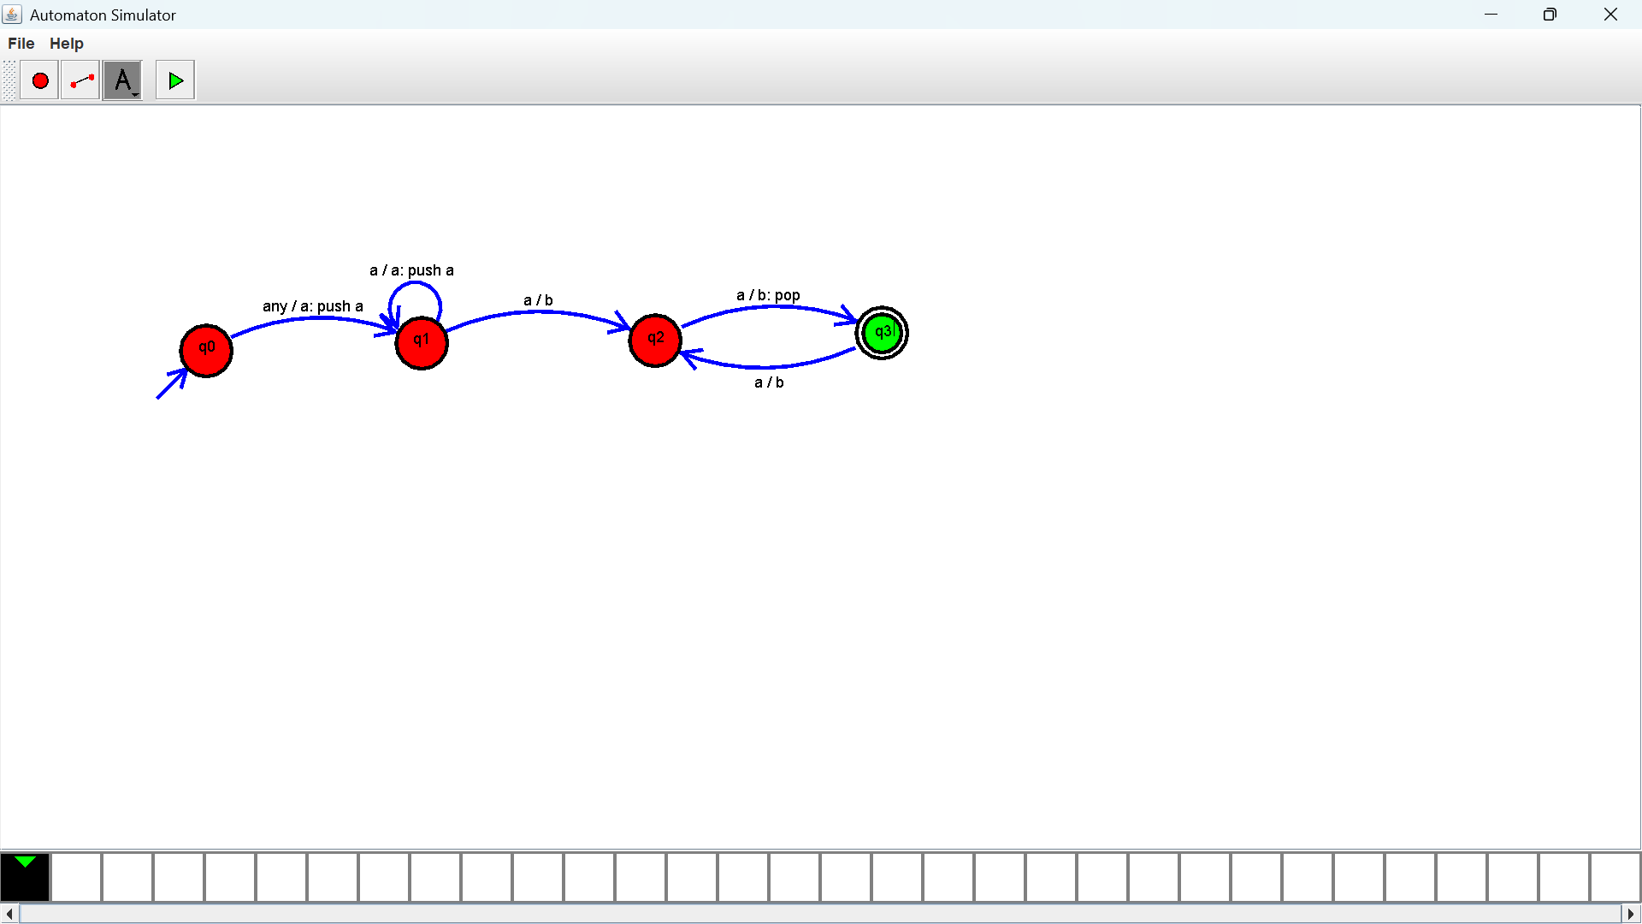

Exercise 15: Design TM using simulator to accept the input string ww
Output :
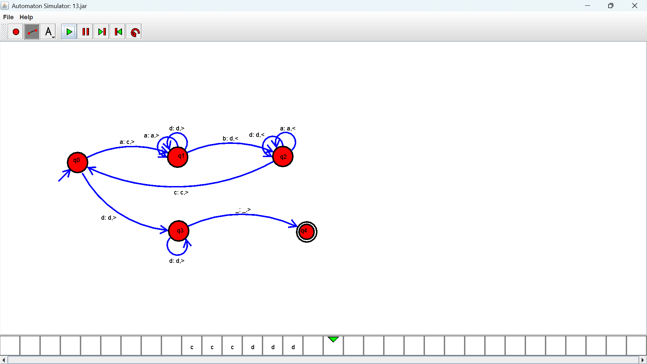

Exercise 16: Design TM using simulator to perform addition of ‘aa’ and ‘aaa’
Output :
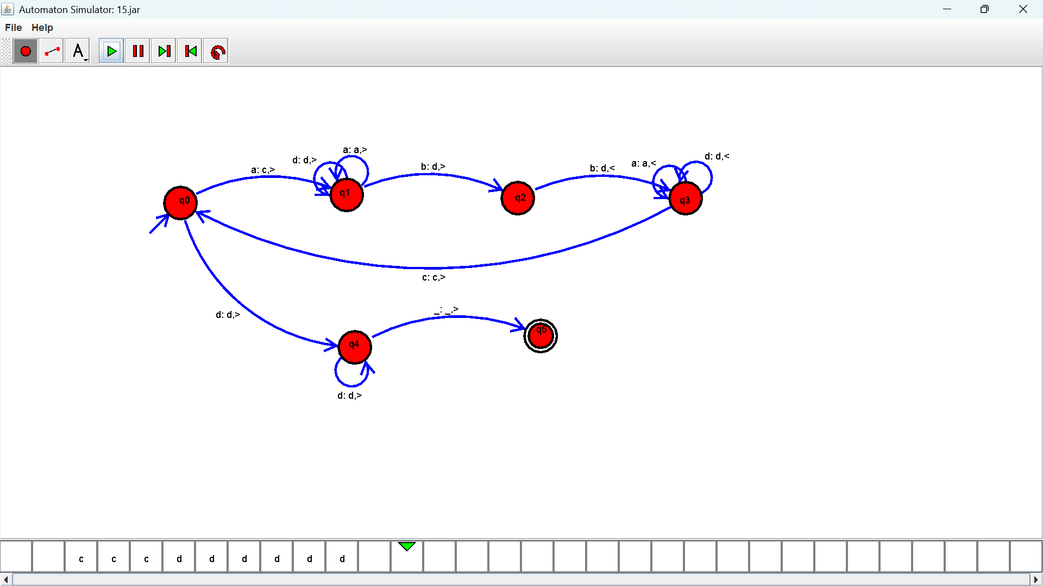

Exercise 17: Design TM using simulator to perform subtraction of aaa-aa
Output :
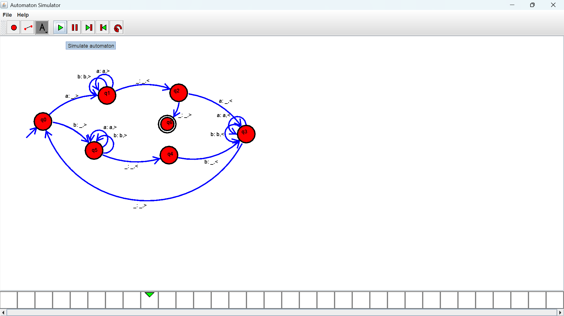

Exercise 18: Design DFA using simulator to accept even number of a’s
Output :

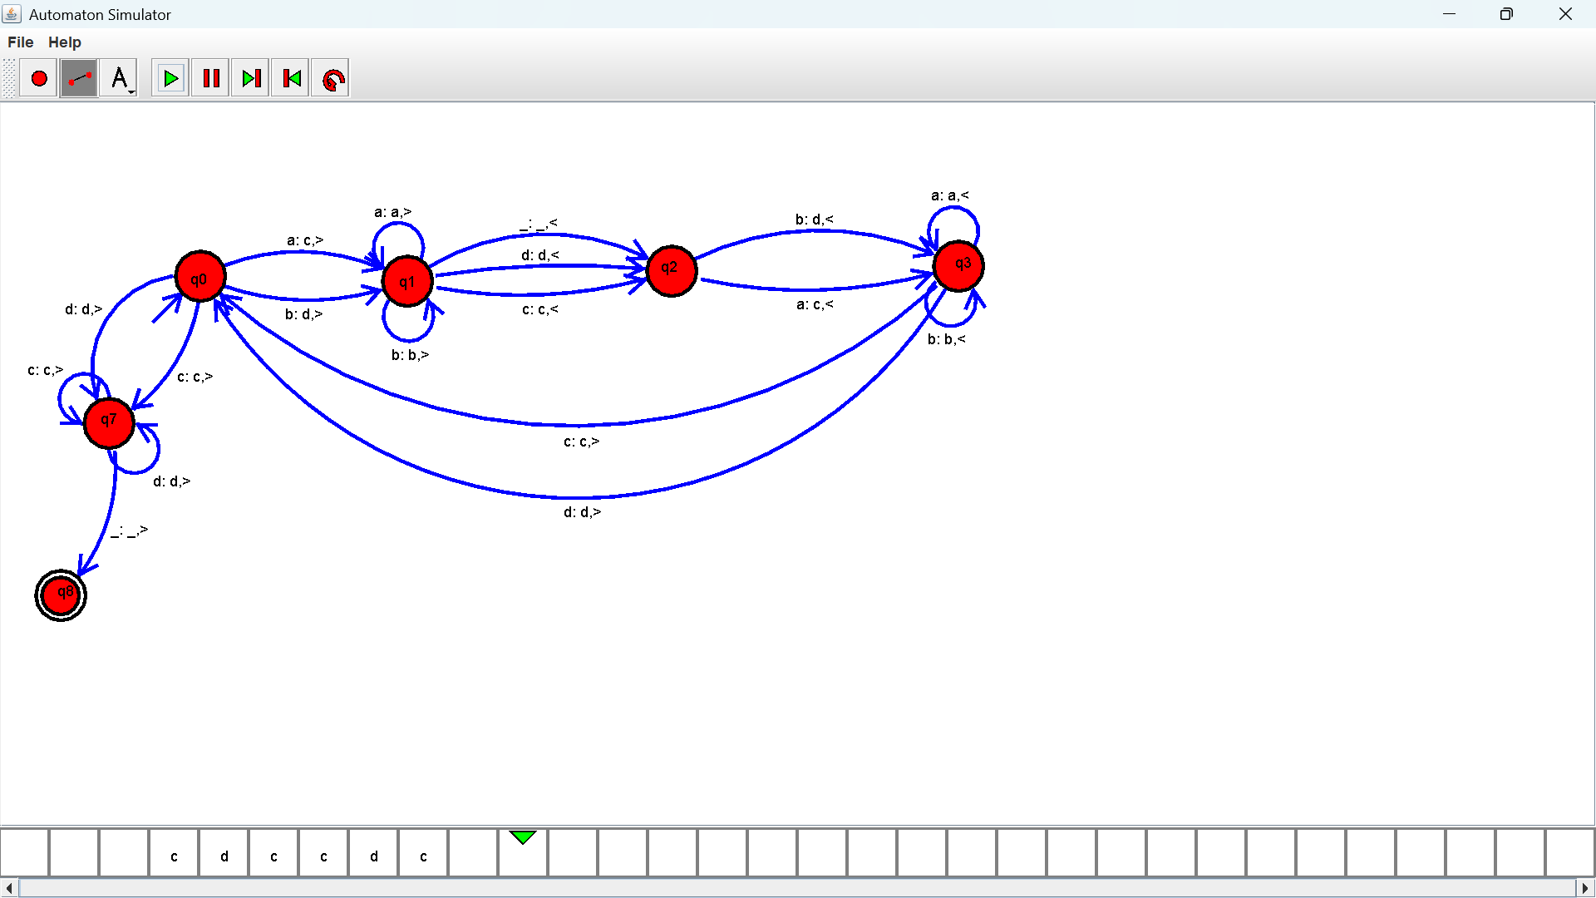
Exercise 19: Design DFA using simulator to accept odd number of a’s
Output :
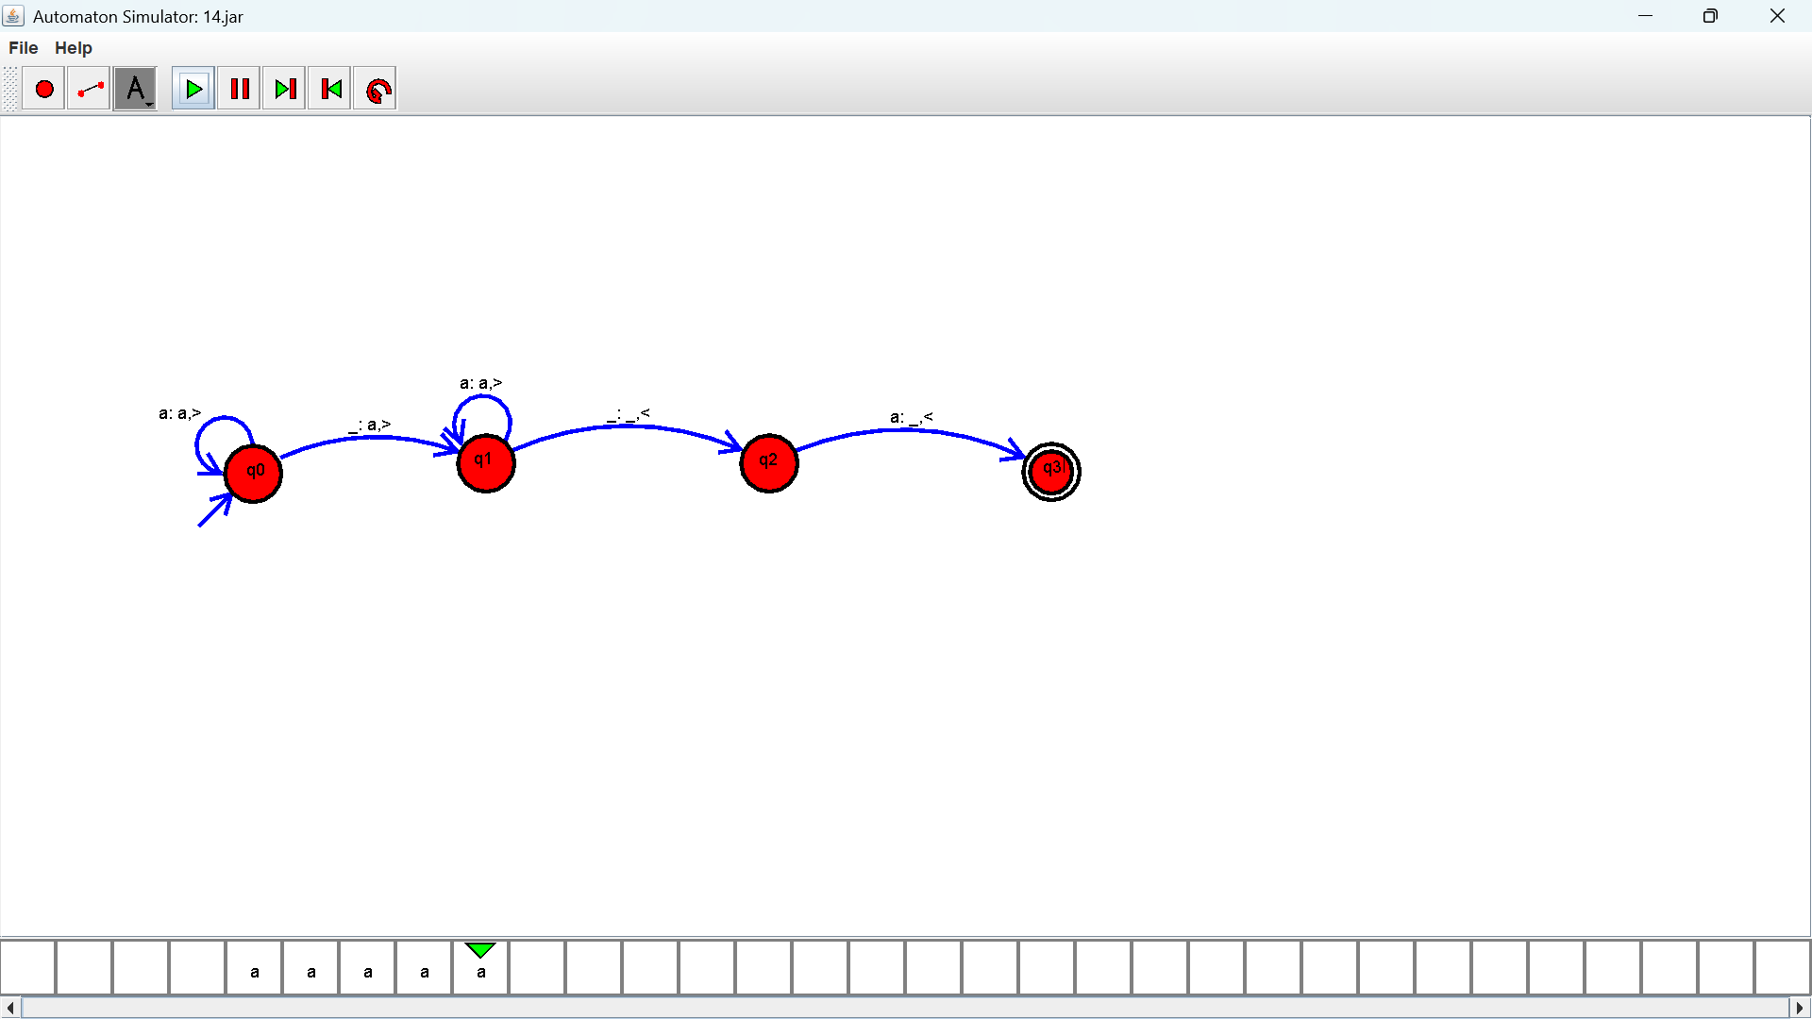
Exercise 20: Design DFA using simulator to accept the string the end with ab over set {a,b) W= aaabab
Output :

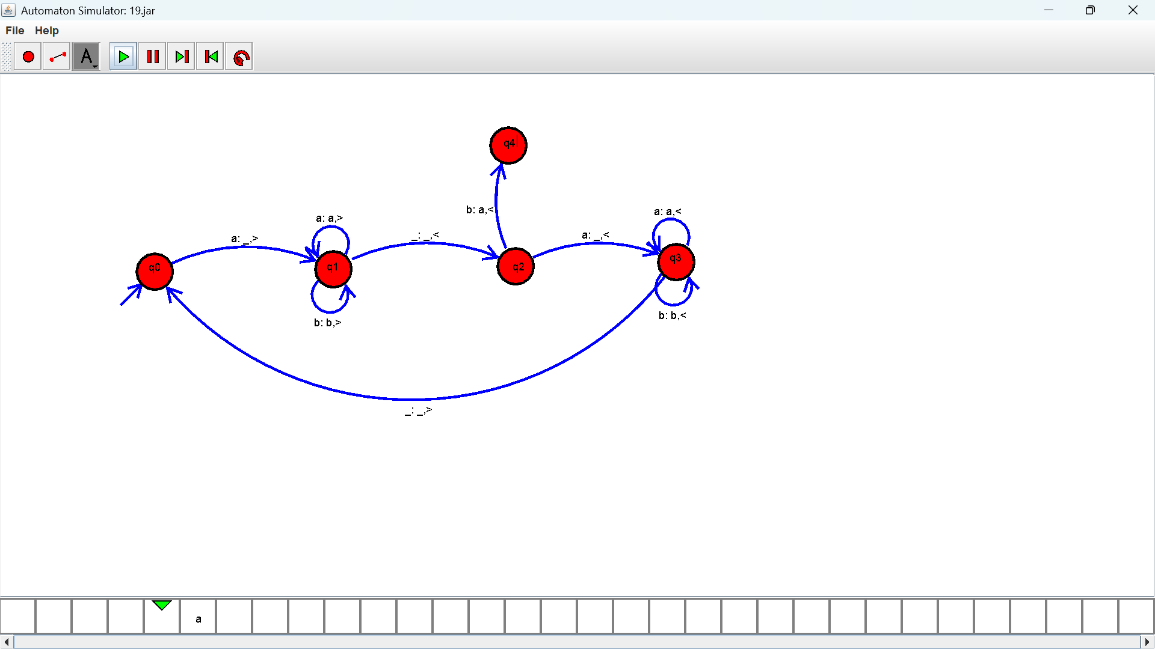

Exercise 21: Design DFA using simulator to accept the string having ‘ab’ as substring over the set {a,b}
Output :
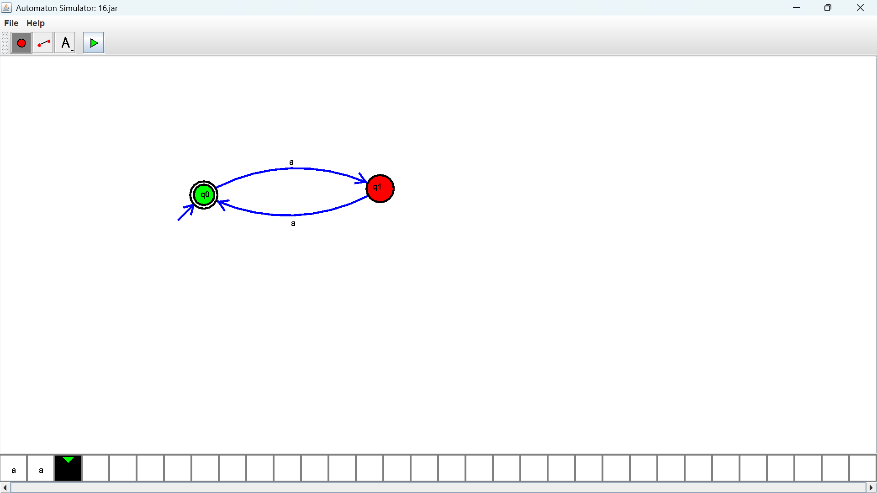

Exercise 22: Design DFA using simulator to accept the string start with a or b over the set {a,b}
Output :
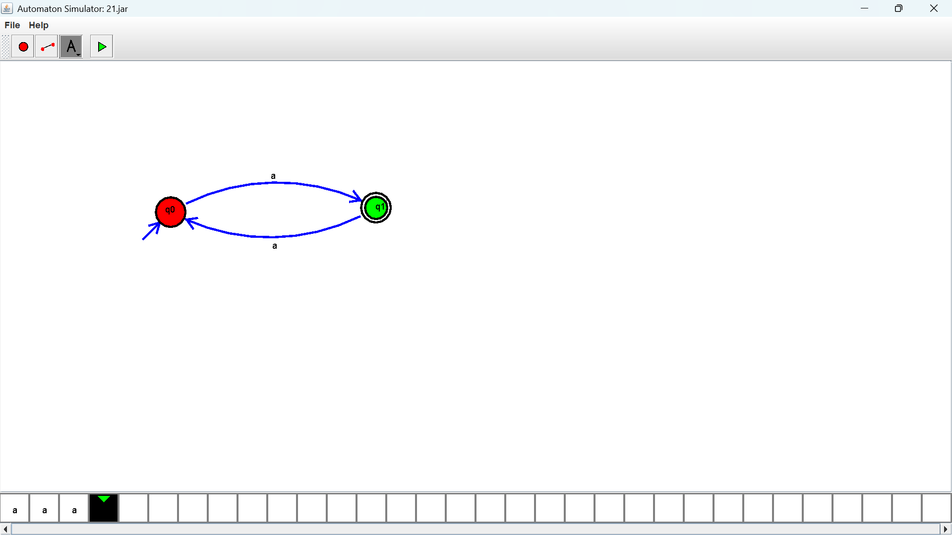

Exercise 23: Design TM using simulator to accept the input string Palindrome bbabb
Output :
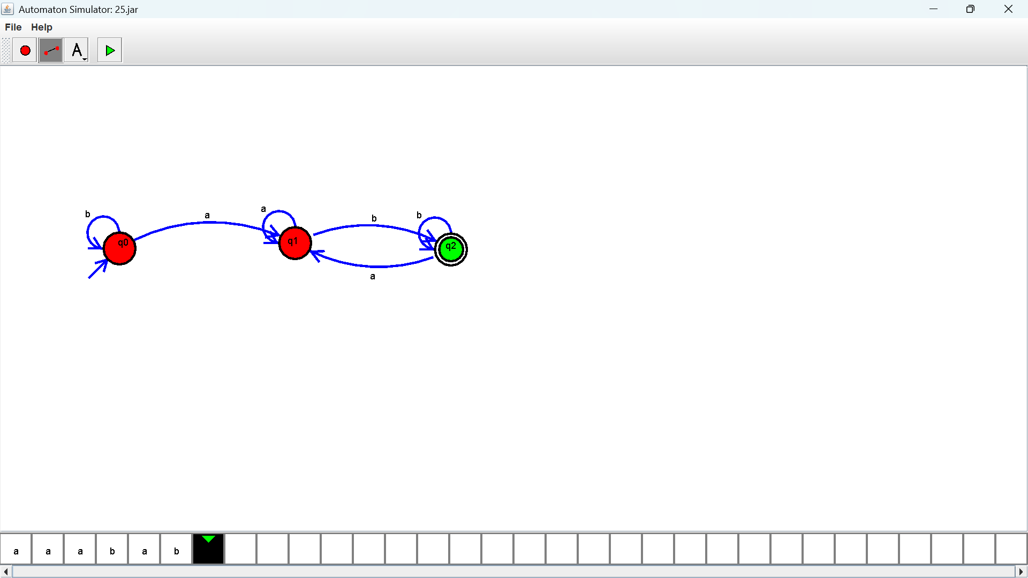

Exercise 24: Design TM using simulator to accept the input string wcw
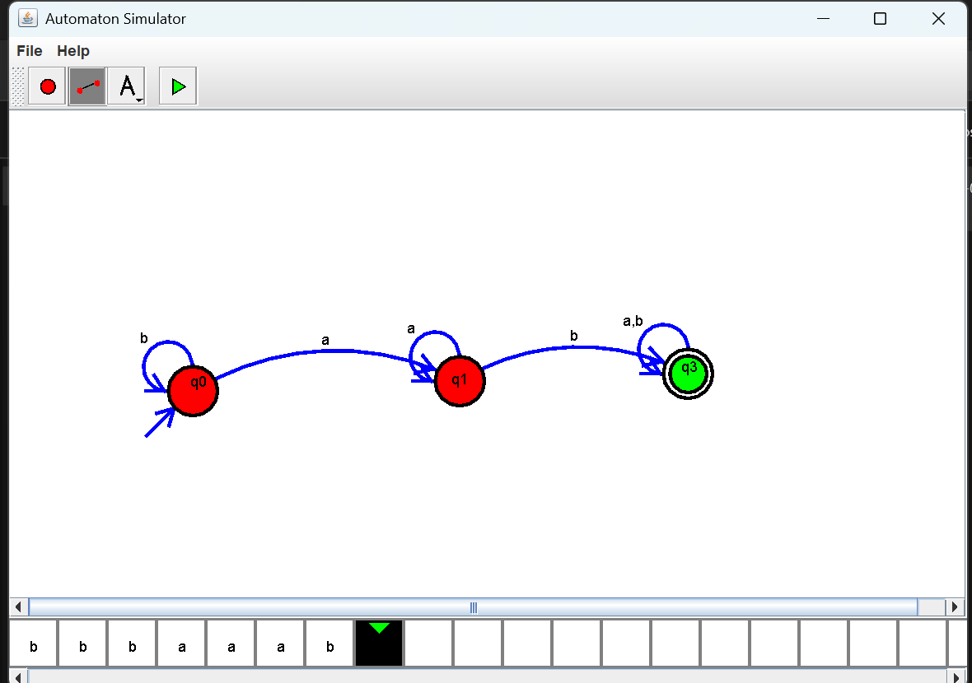
Output :

Exercise 25: Design DFA using simulator to accept the string even number of a’s and odd number of b’s
Output :
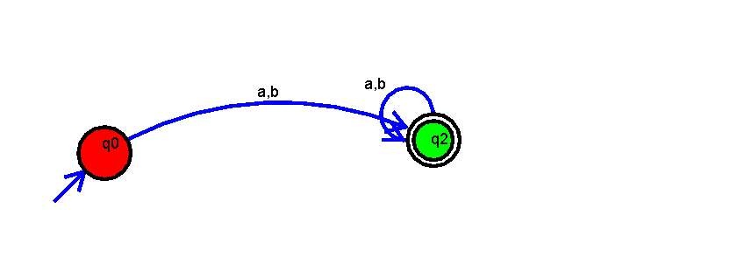

Exercise 26: Design DFA using simulator to accept the input string “bc” ,”c”,and ”bcaaa”
Output :
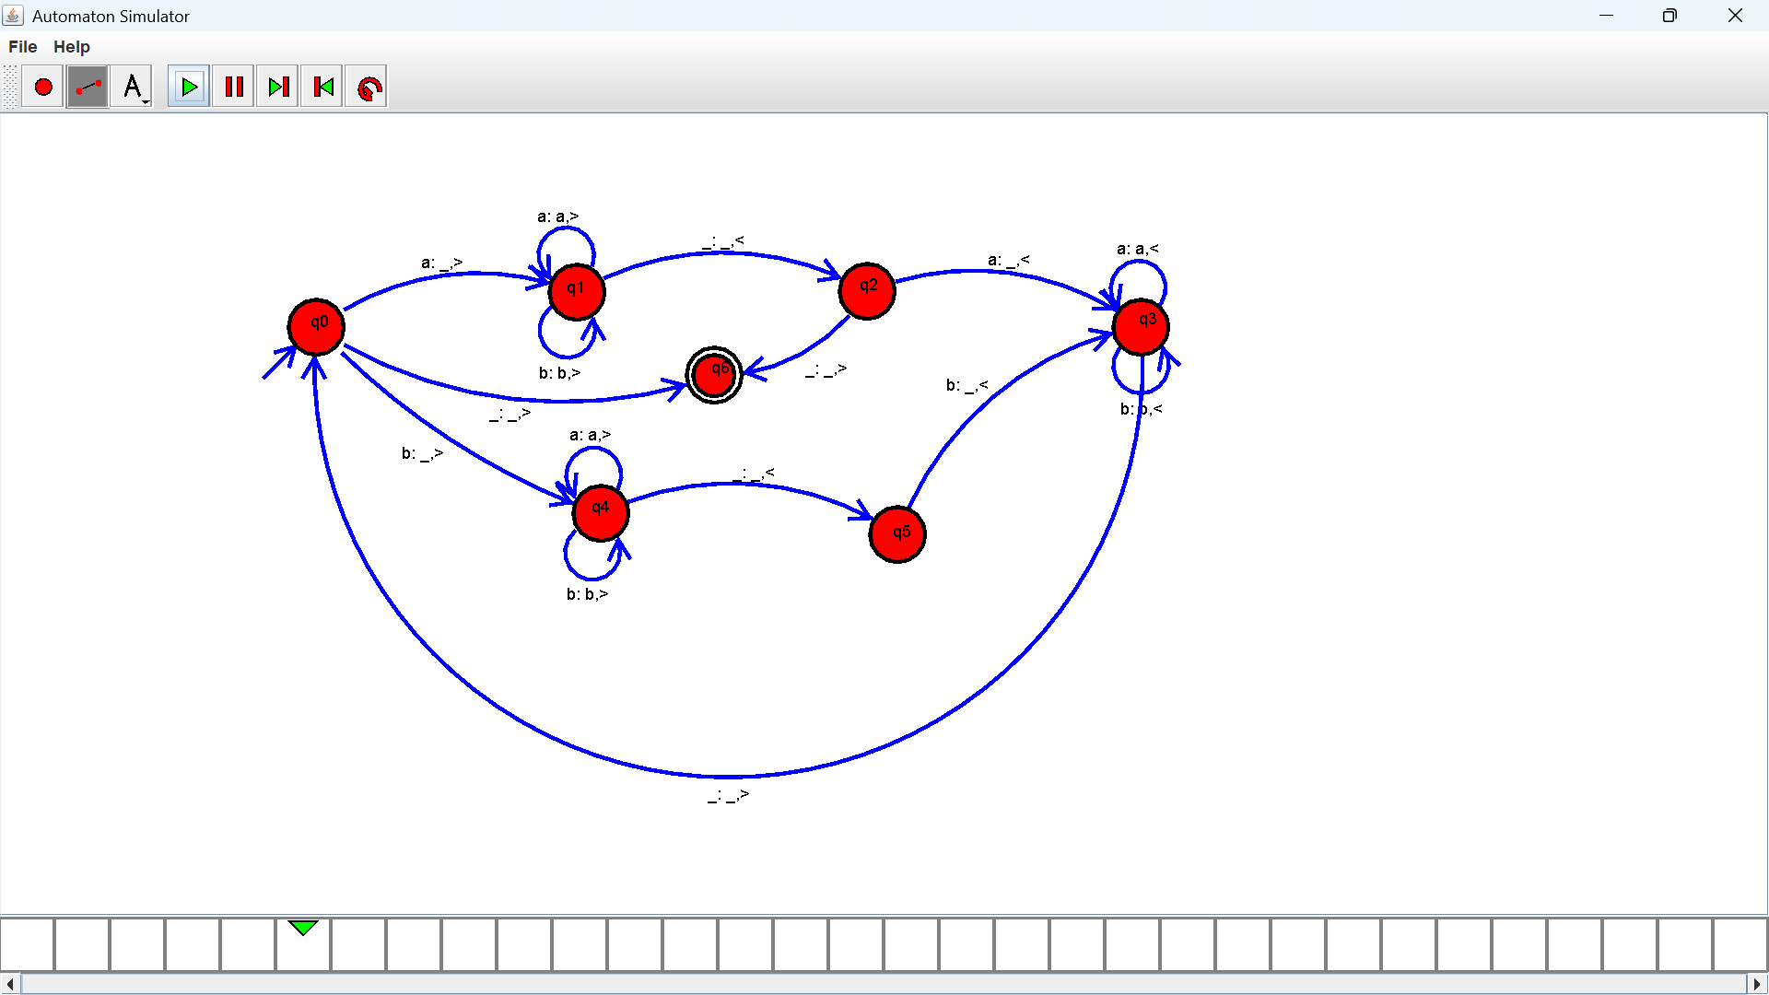

Exercise 27: Design NFA to accept any number of a’s where input={a,b}
Output :

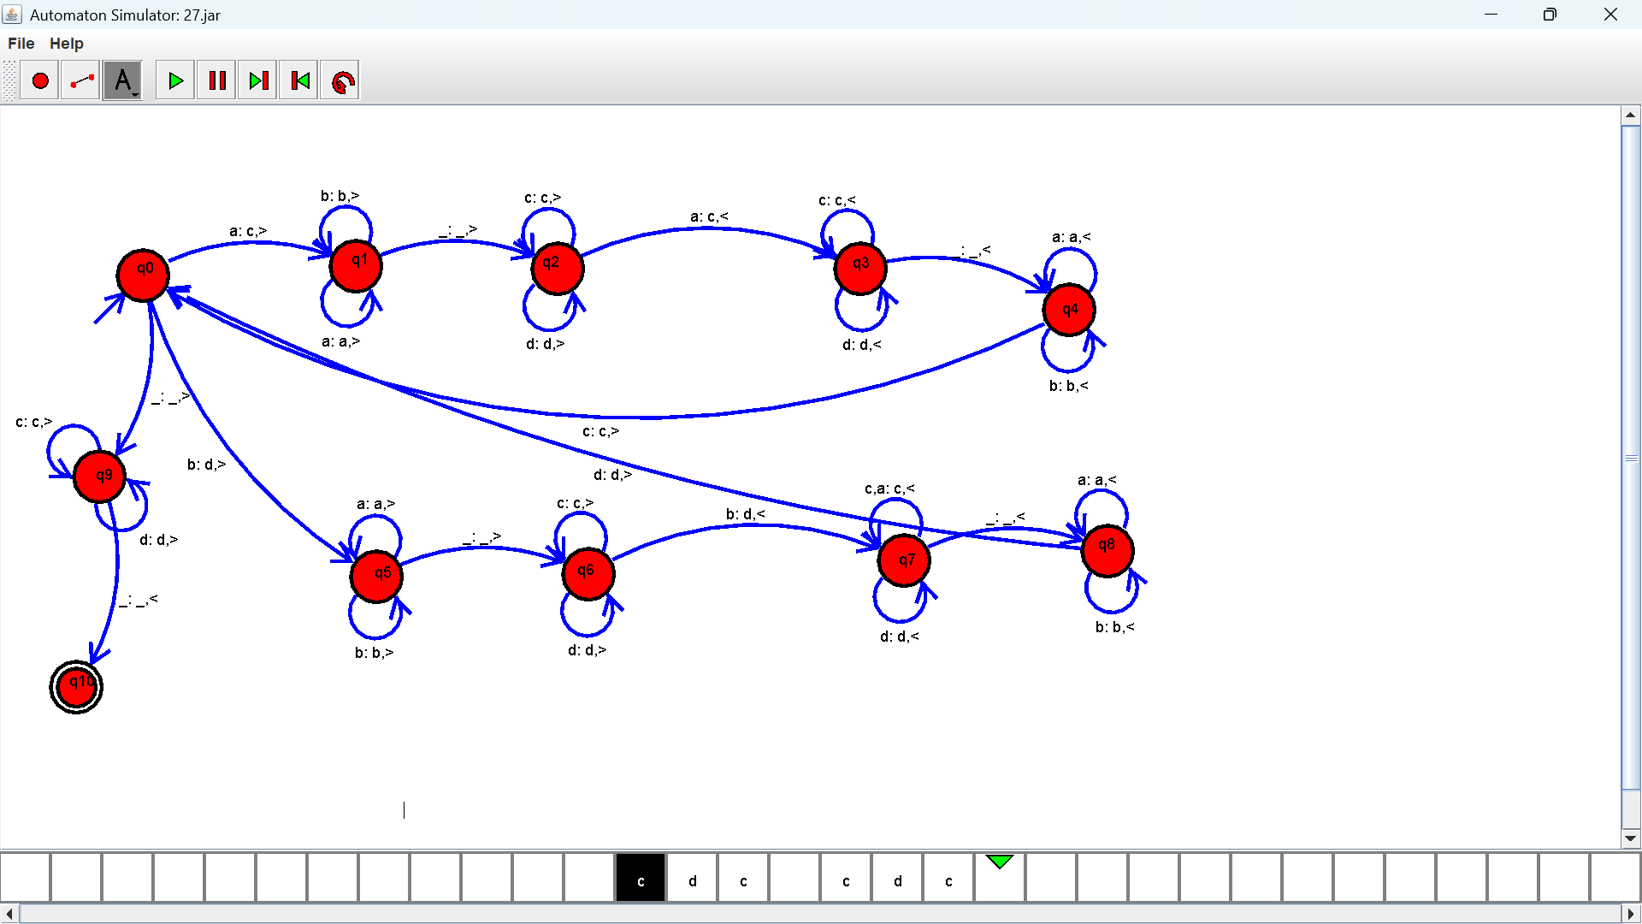

Exercise 28: Design PDA using simulator to accept the input string a^{n}b^{n}
Output :
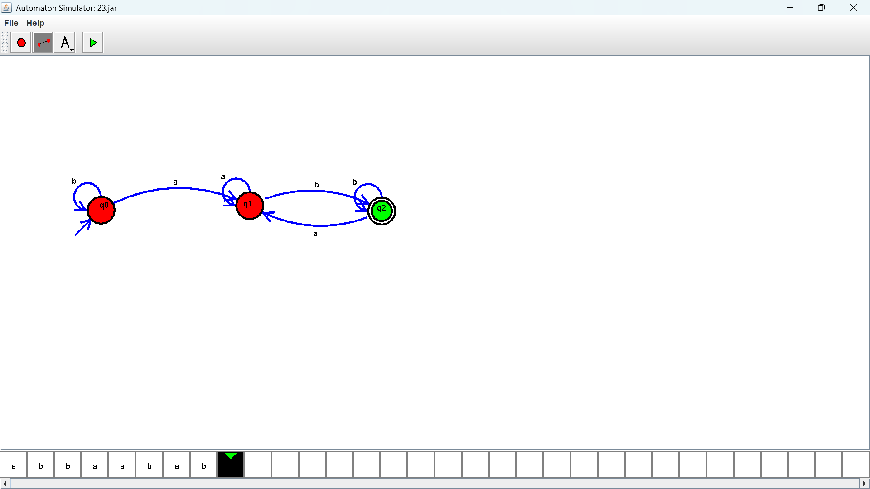

Exercise 29: Design TM using simulator to perform string comparison where w={aba aba}
Output :

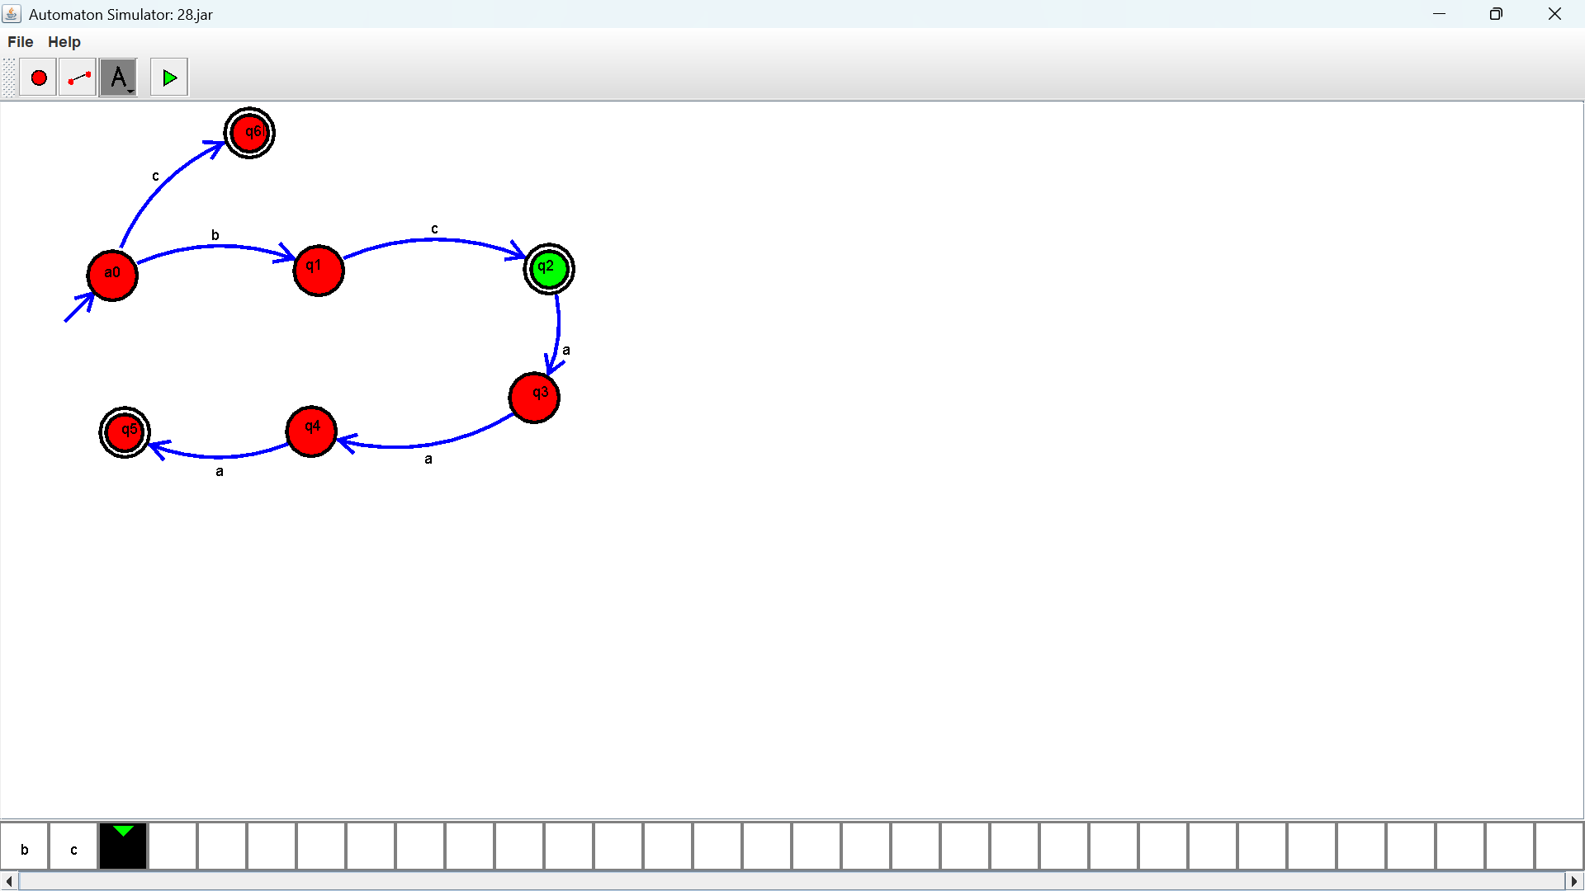

Exercise 30: Design DFA using simulator to accept the string having ‘abc’ as substring over the set {a,b,c}
Output :
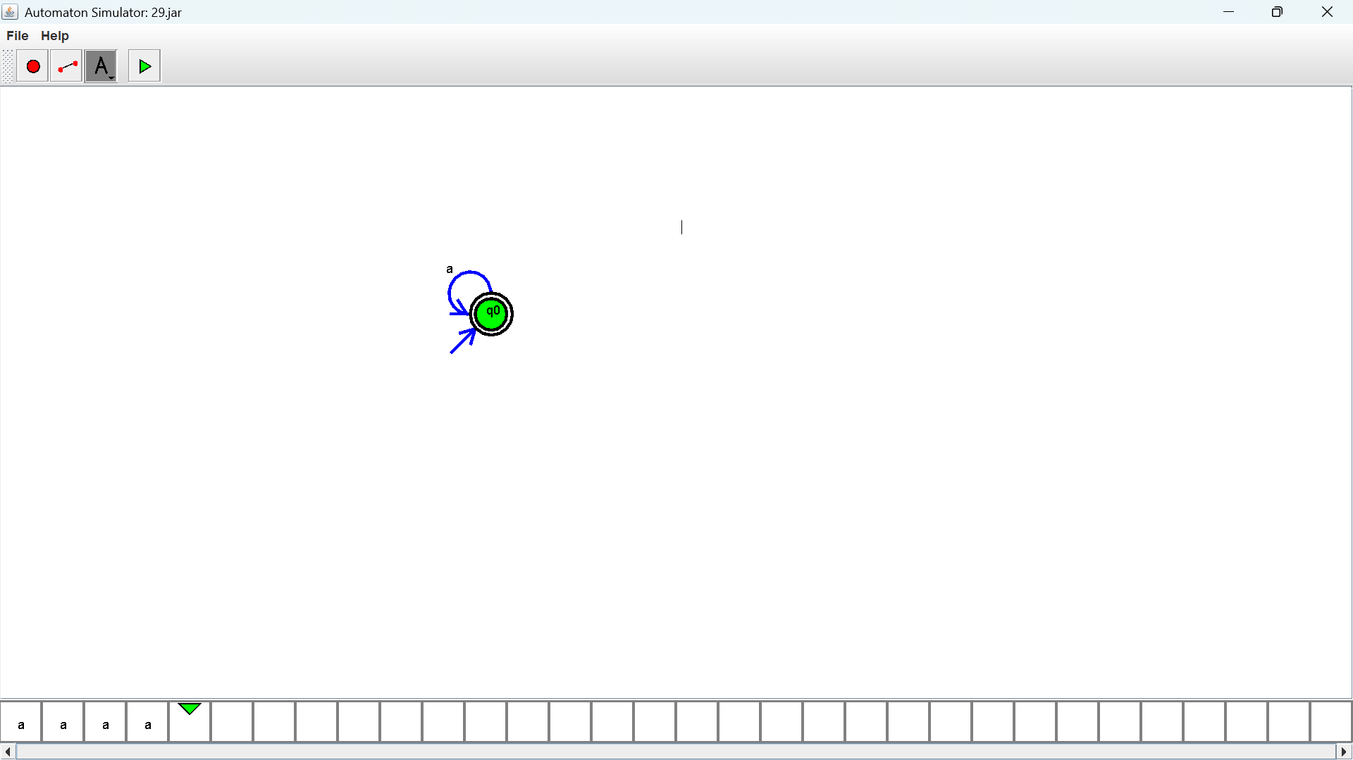

Exercise 31: Design DFA using simulator to accept even number of c’s over the set {a,b,c}
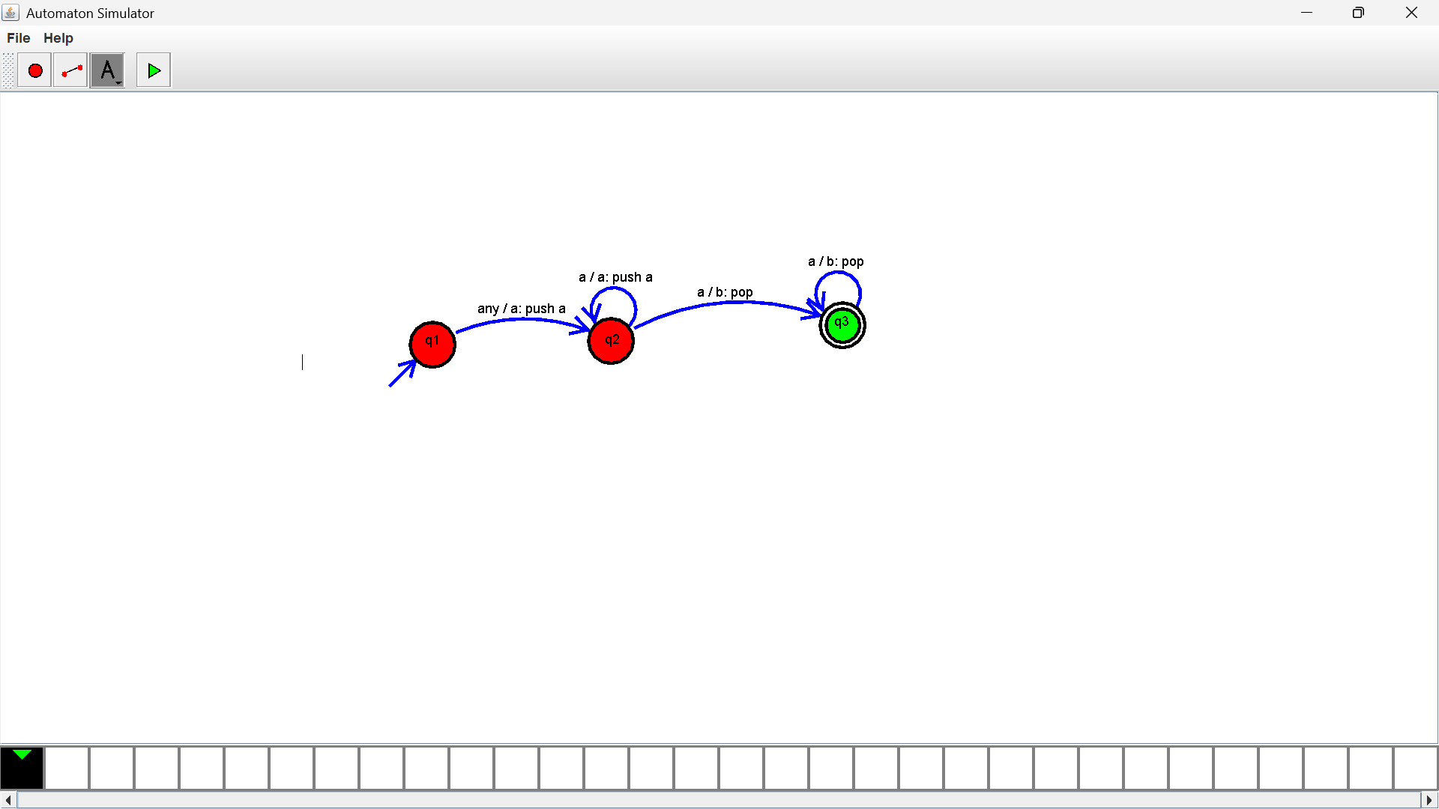
Output :

Exercise 32: Design DFA using simulator to accept strings in which a’s always appear tripled over input {a,b}
Output :

Exercise 33: Design NFA using simulator to accept the string the start with a and end with b over set {a,b} and check W= abaab is accepted or not
Output :
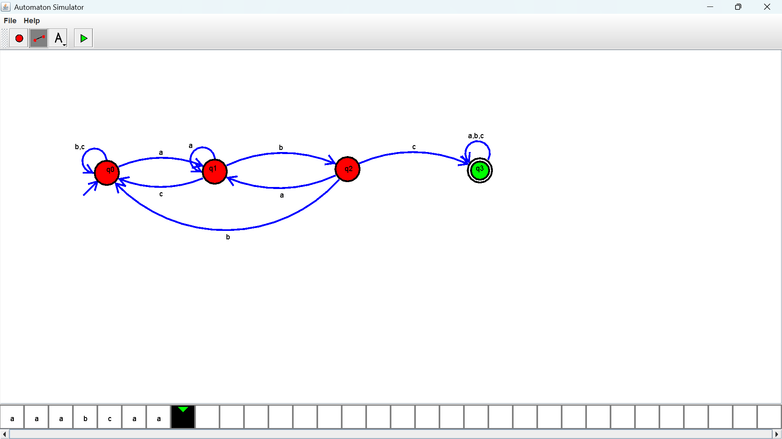
Exercise 34: Design NFA using simulator to accept the string that start and end with different symbols over the input {a,b}
Output :
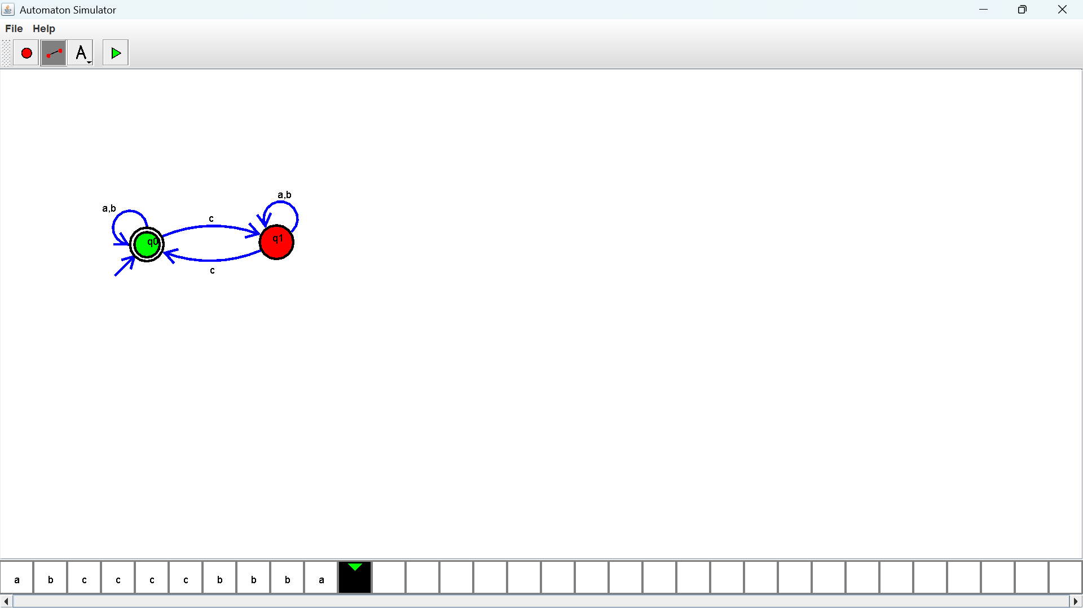

Exercise 35: Let L be regular language, L consist set of string over { a,b) number a’s minus number b’s less than or equal to 2. Design DFA to accept the the language L.
Output :
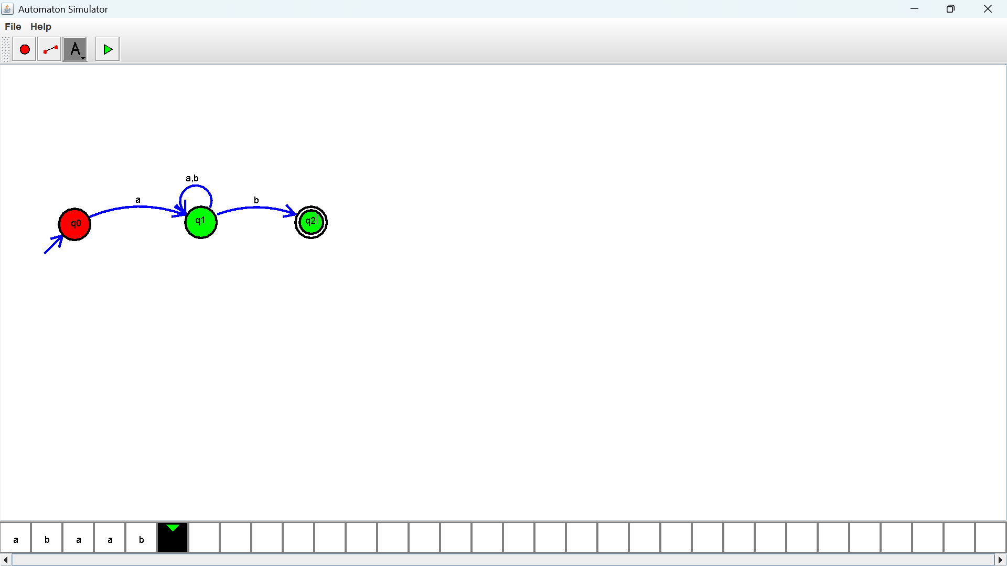
Exercise 36: Design DFA using simulator to accept the string the end with abc over set {a,b,c) W= abbaababc
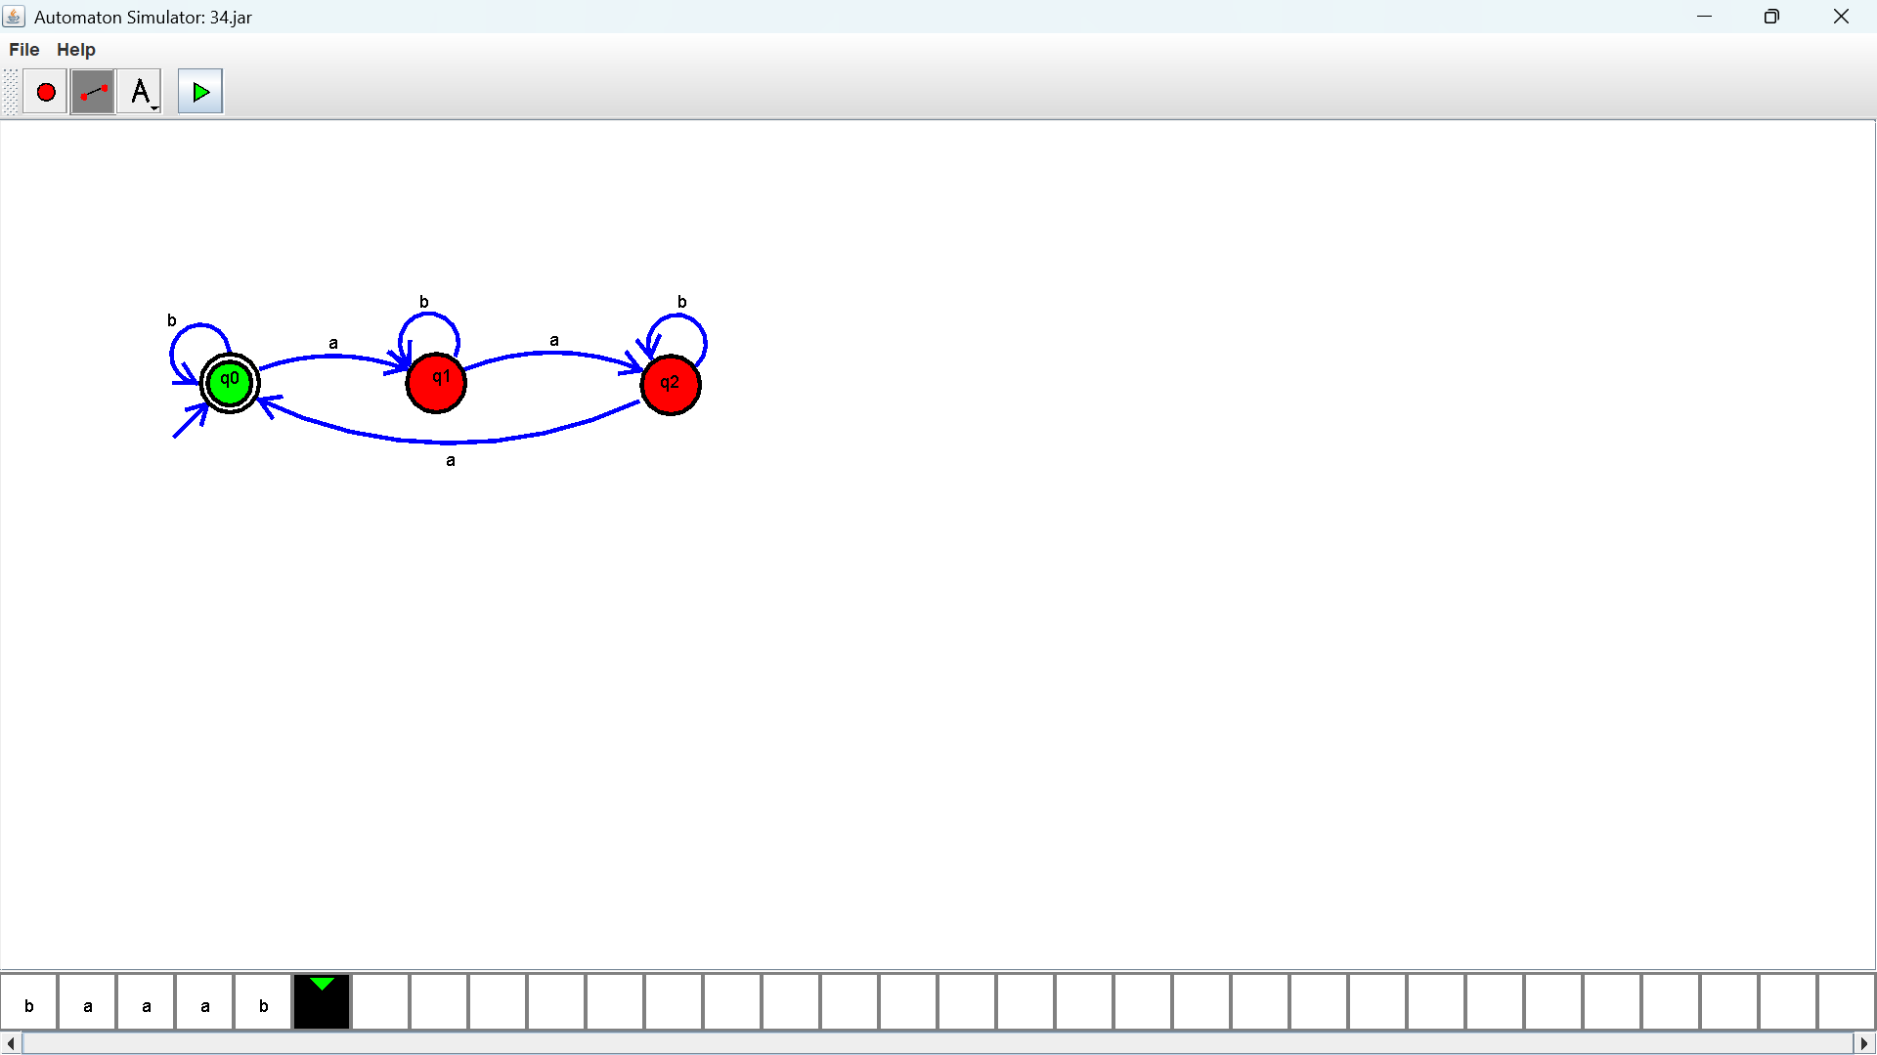
Output :

Exercise 37: Design NFA to accept any number of b’s where input={a,b}
Output :

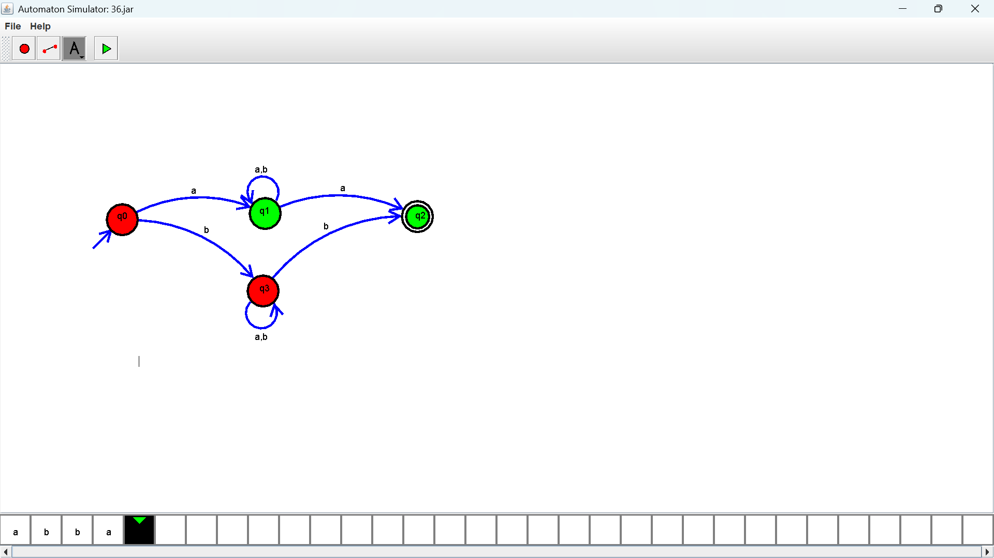
- Exercise 38: The Automatic Teller Machine (Atm)
Output :
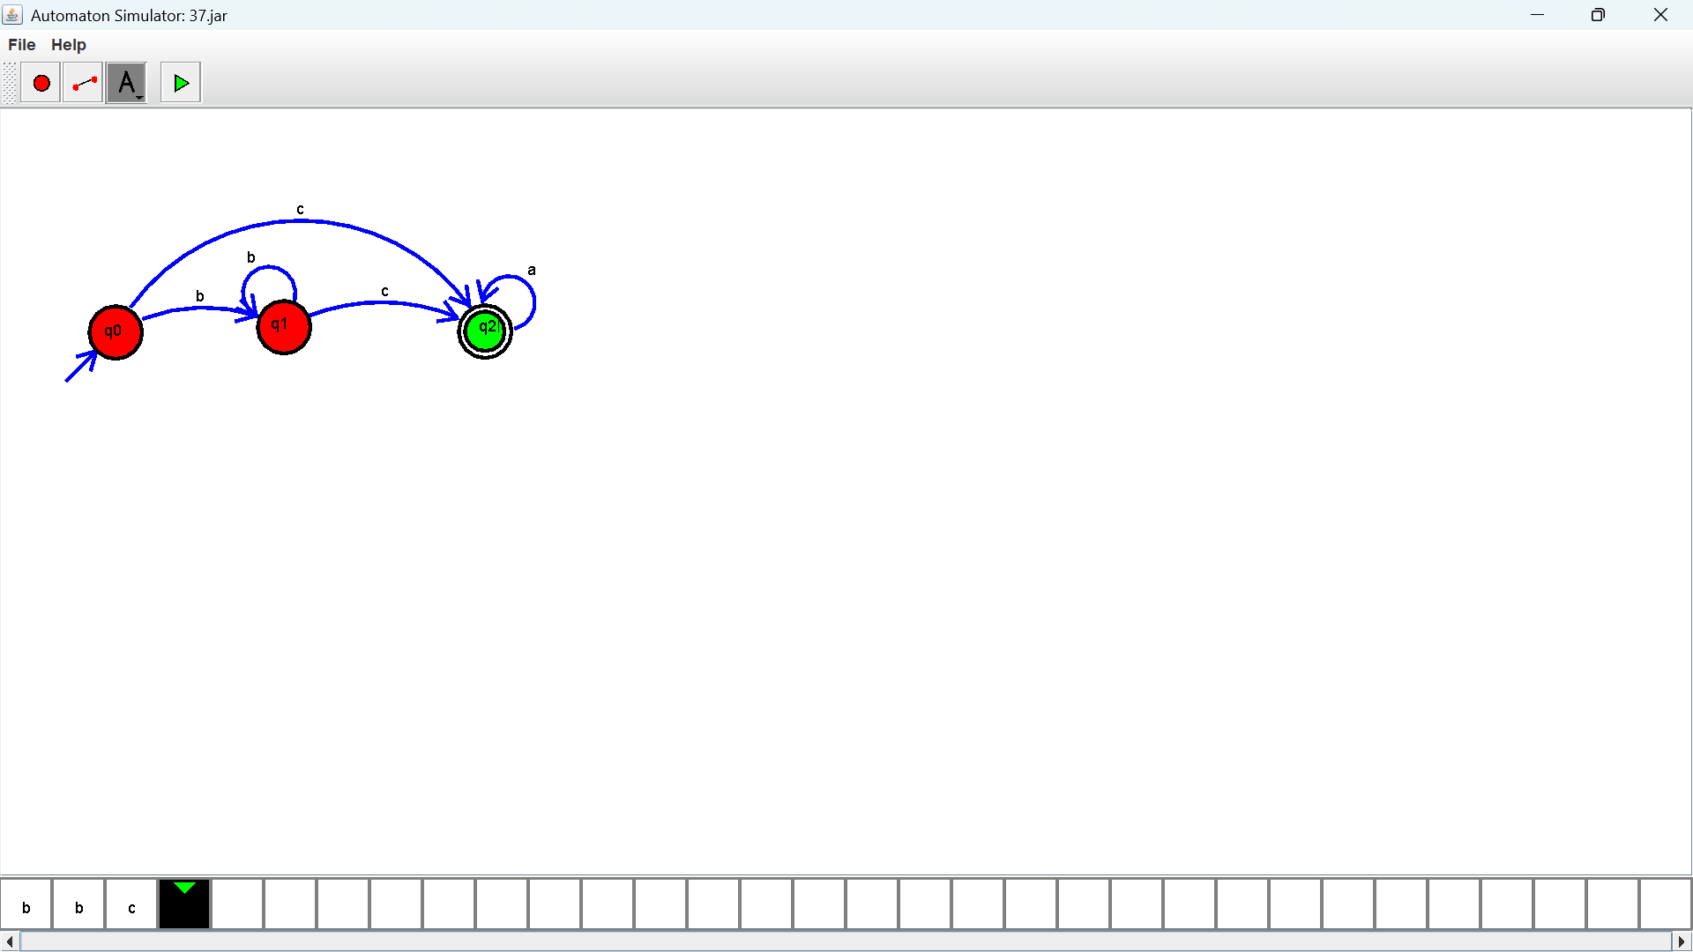
Exercise 39: Pattern Searching
Output :

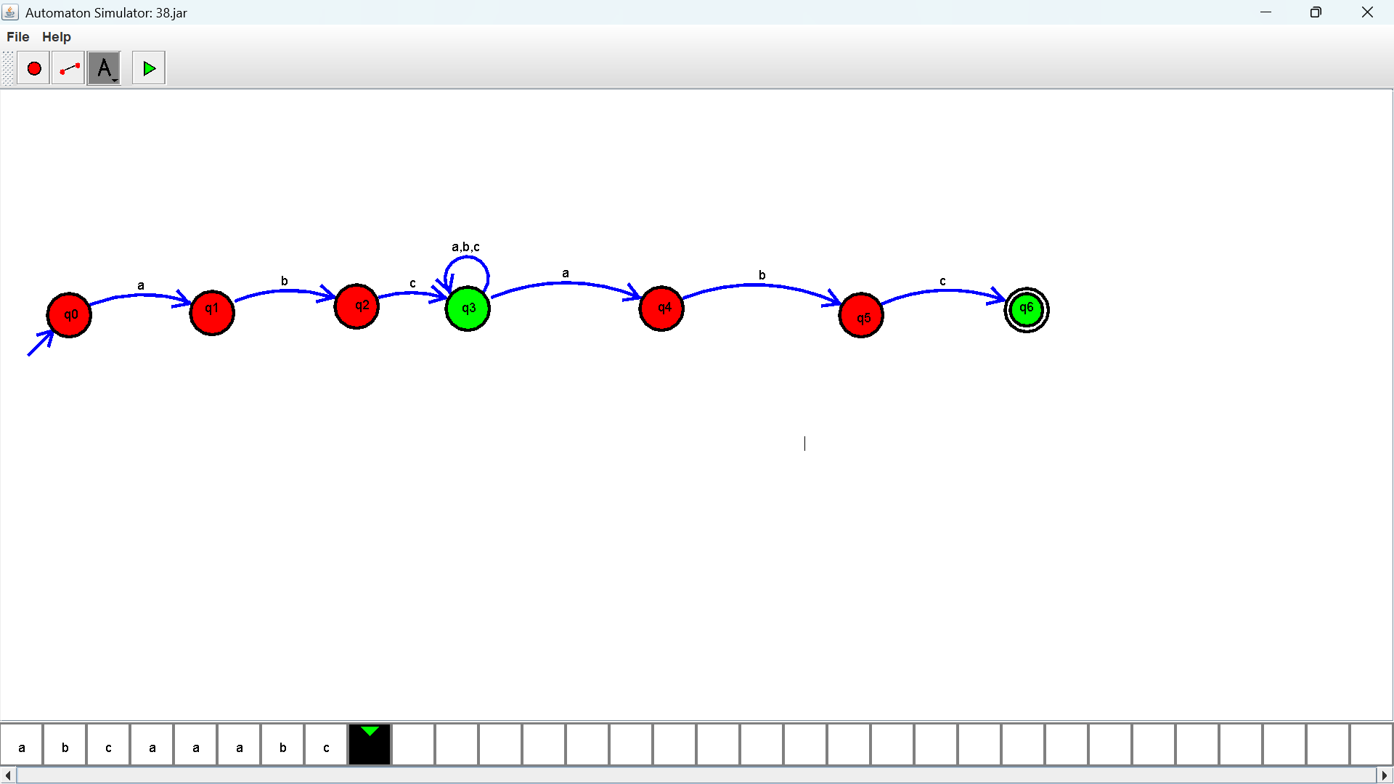

Exercise 40: Vending Machine
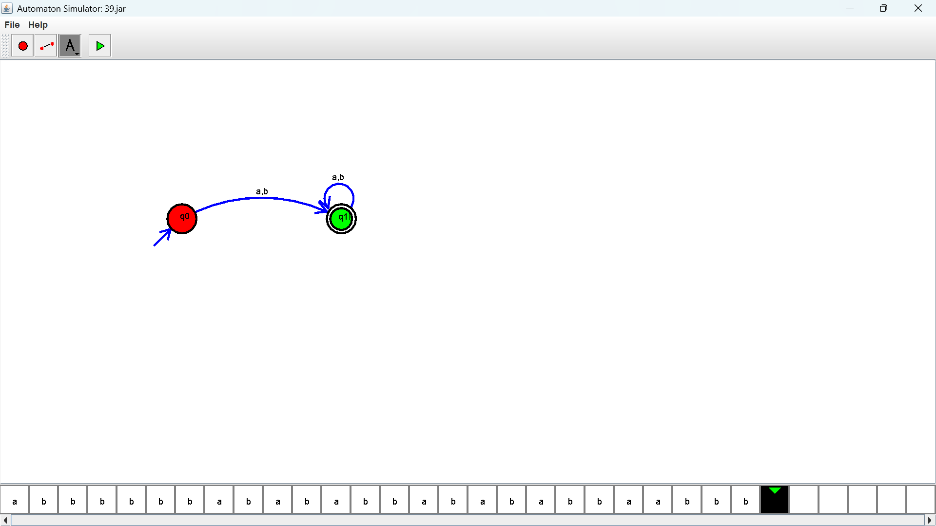
Output :

